**DATABASE SCHEMA DESIGN**

TABLES CREATED

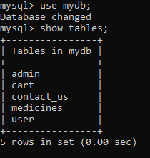

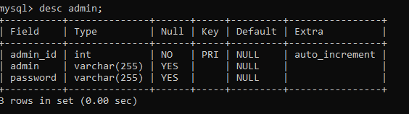ADMIN TABLE SCHEMA

USER TABLE SCHEMA

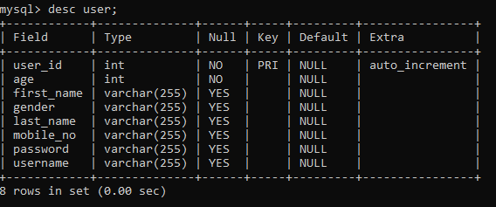

MEDICINE TABLE SCHEMA

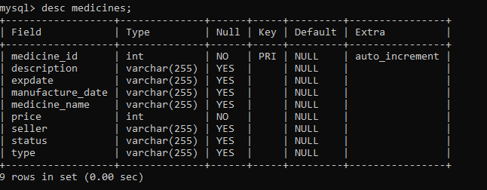

CART TABLE SCHEMA

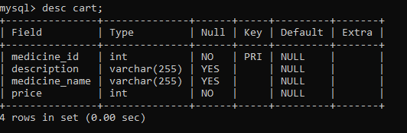

CONTACT US TABLE SCHEMA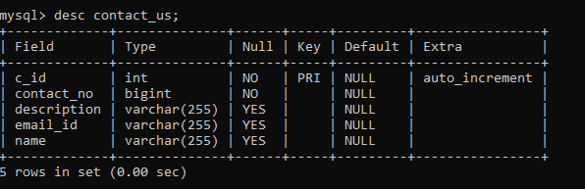

USER TABLE

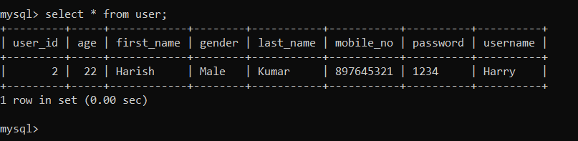

CONTACT_US TABLE

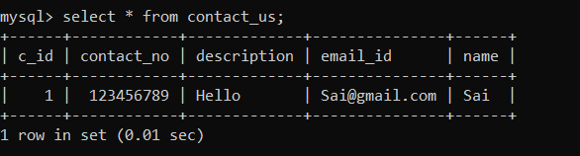

CART TABLE

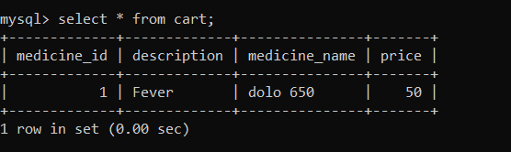

ADMIN TABLE

